What is Data Structure?

A data structure is a way of organizing and storing data in a computer so that operations on it is performed in a efficient way. It refers to the logical or mathematical representation of data, as well its implementation in a program.

Data structures can be classified into two broad categories:

* Linear Data Structure:

A data structure in which data elements are arranged sequentially or linearly, where each element is attached to its previous and next adjacent elements, is called a linear data structure. Examples are array, stack, queue, etc.

* Non-linear Data Structure:

 Data structures where data elements are not placed sequentially or linearly are called non-linear data structures. Examples are trees and graphs.

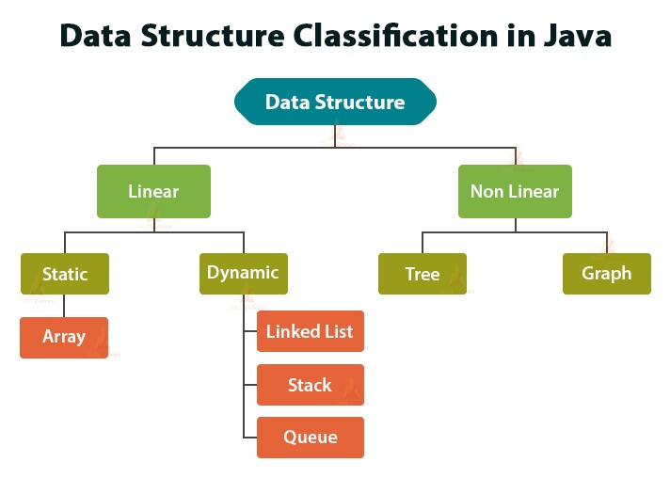

### Advantages of Data Structures:

* **Efficiency:**

Data structures can provide fast and efficient retrieval of data, which is essential in many real-world applications.

* **Flexibility:**

Data structures can provide efficient methods for adding, deleting, and modifying data, which is important in dynamic applications.

* **Reusability:**

Reusable data structures can be used in many different applications, reducing the time and effort required to write and maintain code.

* **Maintainability:**

Well-designed data structures can make programs easier to understand, modify, and maintain over time.